

Faculty of Computing

SECJ2154 (OOP)

PROJECT PROPOSAL

Mini Project Title:
Lost and Found Reporting System

Group Members:
- CHAU YING JIA (A23CS0213)
- NAWWARAH AUNI BINTI NAZRUDIN (A23CS0143)
- MOHAMED ALI (A21EC0287)
Mini Project Description
- Introduction
The Lost and Found Reporting System aims to assist students and campus staff in efficiently reporting lost or found items. It offers a centralized platform where users can log reports, monitor item statuses, and manage records of found property. This system helps reduce confusion and improve the chances of recovering lost items through organized digital tracking.

- Problem statement
Currently, the reporting and tracking of lost or found items is primarily carried out in a manual or informal manner, often relying on notice boards or social media. This approach results in challenges such as tracking difficulties, duplicate reports, and miscommunication. To address these issues, we suggest implementing a digital system that enables users to report lost or found items, manage their statuses, and maintain a structured record of all reports.
- Class Diagram of the project

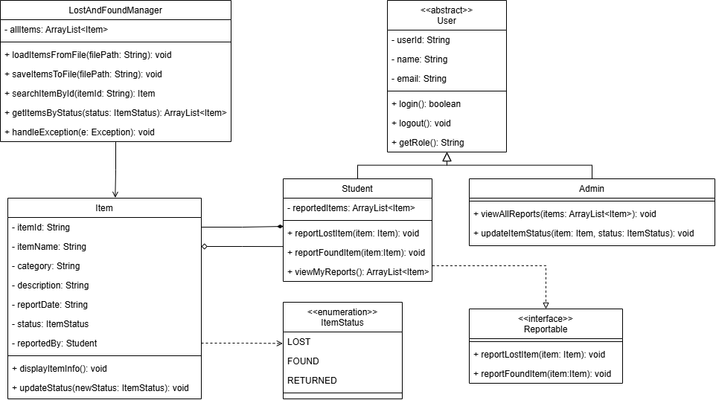

Person-in-charge | Classess
Chau Ying Jia | 1. Student  2. LostAndFoundManager
Nawwarah Auni | 1. Admin  2. Item  3. Reportable
Mohamed Ali | 1. User  2. ItemStatus

- TECHNIQUES/SOFTWARE/TOOLS BEING USED,
State or tick the main concept of Java Programming to be used in this project ENUM ASSOCIATION*
ARRAY LIST /.VECTOR COMPOSITION
ARRAY AGGREGATION
ARRAY OF OBJECTS INHERITANCE*
FILE* STATIC METHOD
POLYMORPHISM* ABSTRACT CLASS*
INTERFACE CLASS* EXCEPTION HANDLING*
GUI APPLICATION Others:

- *compulsory – also comments, style etc
- State tools, apps or software to support this mini project.

Project proposal submit by the leader through E-learning before or at 16 ^{th} June 2025 (Monday)

